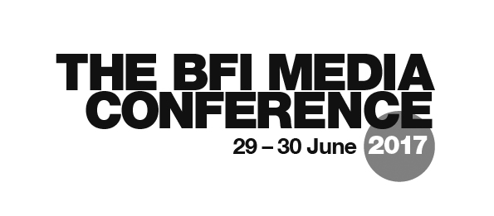

OPTIONAL SESSIONS: SELECTION FORM

For each of the sessions, indicate your preferences by numbering each box from 1 (most preferred) to 5 – ticks aren’t enough! Please return this form with the Media Conference 2017 Application Form and payment.

NAME:

THURSDAY 29 JUNE
Session 1  09:15-10:15 | Specification Support Workshop: AQA Film Studies & Media Studies  Specification Support Workshop: OCR Film & Media  Specification Support Workshop: WJEC Film Studies  Specification Support Workshop: WJEC Media Studies  BFI Education: Schools, Future Film, Film Academy Programmes 2017-18
Session 2  12:00-13:15 | INDUSTRY Video Journalism: DIY Shoot, Light, Edit, Produce, Report  INDUSTRY Apprenticeships and More! Ways into Film and TV Production  TEACHING Film Language: Mise en scène  TEACHING Film Form, Narrative and Ideology  RESEARCH News, Social Media and Young Consumers
Session 3  14:15-15:30 | INDUSTRY Video Game Design  INDUSTRY Understanding Audiences: Data, Market Research & Ethnography  TEACHING Ideology with Experimental Film  TEACHING When is a TV Genre Not a TV Genre?  RESEARCH The BBC: Myth of a Public Service
Session 4  16:00-17:15 | INDUSTRY Feature Film Script Editing  INDUSTRY Making TV Documentary: Exodus  TEACHING Planning a Two Year Media Studies Course  TEACHING Student Collaboration and Entrepreneurship through Film Production  RESEARCH Through Class Darkly: Class in British TV Noir

FRIDAY 30 JUNE
Session 5  9:15-10:30 | INDUSTRY Creating an Advertising Campaign  INDUSTRY BBFC Age Ratings, Audiences, Classification and Context  TEACHING Resourcing the New Specifications: The BFI National Archive in the Mediatheque  TEACHING Non-English Language Long-Form TV Drama  RESEARCH Film Market Realities: The British Film Industry in Numbers
Session 6  12:00-13:15 | INDUSTRY Documentary and VR  INDUSTRY Music Video  TEACHING Female Spectatorship and the Female Protagonist  TEACHING Is What We Know About Fake News True?  RESEARCH Children’s Media Lives: Ofcom Study of 8-17-year-olds
Session 7  14:15-15:30 | INDUSTRY The A-Z of Short Film Production: We Love Moses  TEACHING Cross-Media Projects  EDUCATION PLENARY David Gauntlett
Session 8  16:00-17:15 | INDUSTRY Film Distribution: From Moonlight to Lady Macbeth  INDUSTRY Marketing and Brand Partnerships  TEACHING Video Games  TEACHING Independent and Group Practical Production  RESEARCH Nordic Noir in the UK: The Allure of Accessible Difference

