International Fund  UK Film Focussed Activity at Festivals,  Markets and other Platforms  Application Form  Please provide the following details for initial assessment by the BFI international team. We will respond within 2 weeks if we think that there is potential for funding. If so, we will invite you to submit more detailed information for further consideration.  THIS FORM SHOULD BE COMPLETED WITH REFERENCE TO THE GUIDELINES FOR APPLICANTS WHICH SHOULD BE READ CAREFULLY IN FULL BEFORE COMPLETING THE FORM. |  |  |  |  |  |  | 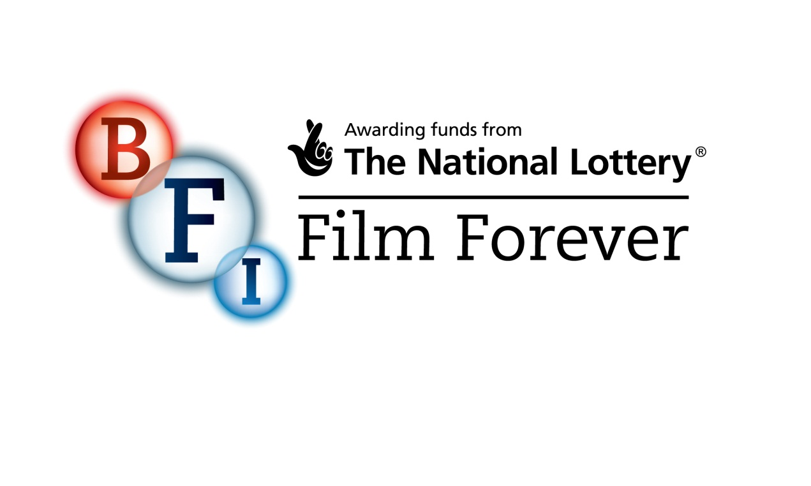
 |  |  |  |  |  |  | For BFI use only
Date received:

URN:
SECTION 1: Applicant Information
Please fill in the details of someone from your organisation who knows about your planned activity. This is normally the person signing the form and the person expected to sign any funding agreement with the British Film Institute.
Applicant Organisation Name
Contact
Position in Organisation
Address
Town/City
Country |  |  |  |  | Post Code
Telephone(s)
E-mail
Website
If you have any specific communication needs, please tell us what they are:
Text phone |  |  | Sign Language | Other (please specify below)
SECTION 2: Festival, Market or Platform details
Name of event:
Dates of event:
Please provide a description of the festival, market or platform (max 500 words):

SECTION 3: The Proposal
3.1 Please provide a proposal for the UK related activity at the festival, market or platform (max 500 words):
3.2 Please outline the benefits to UK film in your proposal, taking into account the criteria in the guidelines (max 500 words):

3.3 Please provide an indicative budget for the UK focussed activity, the amount of funding you would like BFI to contribute towards that activity and an indication of how the remainder of the costs of the UK focussed activity will be met*
Total indicative budget for the UK focussed activity (in £): | £
Requested contribution from BFI (in £): | £
Source and amount of other funding: | Confirmed: | Not confirmed:
*Please note that you need to ask for funding in UK £ (sterling).

If your budget is in another currency please provide a Pound Sterling equivalent of the total figure.

Please note that your application will not be considered without all the information requested above.

SECTION 4: Declaration
The British Film Institute is required to identify all relevant financial or personal interests that may exist between board members or employees of the British Film Institute and applicants. This is to ensure that measures can be introduced to prevent a conflict of interest arising between those persons assessing the application for the British Film Institute and such applicant. For these purposes please complete the statement below:
“I (or the person/company on whose behalf I am applying) do / do not* have any financial and/or close personal relationship with any Trustee or employee of the British Film Institute.”

*Delete or insert details as applicable
The nature of such relationship is as follows” (e.g. spouse, relative, financial interest - please specify details below):
I have read and understood the British Film Institute’s application guidelines. The information I have given on this application is true and correct. Any material I have sent to support my application is also true and correct. I will tell you immediately if this information or the supporting material needs to be updated. I am happy for you to provide copies of this form and any supporting material to any person or organisation you wish to consult about my application. I am authorised to make this application and accept a conditional offer. I also have the authority to repay the British Film Institute in the event of the conditions not being met.
Signature:
Date:
Data Protection
Part or all of the information you give us will be held on computer and used for statistical purposes. It will also be used for the administration of applications and awards. We may provide copies of the information in confidence to individuals or organisations who are helping us assess applications or monitor funding and may also be shared in connection with these purposes with other companies in the British Film Institute group of companies.
Incomplete applications will not be eligible for consideration.
Please submit your application form to: morgana.sneddon@bfi.org.uk

BFI International Fund Application Form
- Additional Information

We are committed to pursuing equality of opportunity. Monitoring applicants and applications is one way of helping to ensure that there is no discrimination in the way applications are assessed. The information you provide on gender, ethnic origin and disability will be used for monitoring purposes only. This section will be separated from your application upon receipt and the information it contains will not influence your application in any way.
Please note you will need to return this form as part of your application, providing any of the information requested is optional.
 |  | Number
Number of people working on the activity full or part-time for a minimum of 3 months
(please remember to include yourself as applicable)
Of the people included in your total above, how many are:
Gender: |  | Number
Male
Female

Ethnic Background:
This information should be self assessed, therefore please give your colleagues the opportunity to select the description which best applies.
 |  | Number
Asian or  British Asian: | Indian
 | Pakistani
 | Bangladeshi
 | Any other Asian background
Black or  British Black: | Caribbean
 | African
 | Any other Black background
Mixed: | White and Black Caribbean
 | White and Black African
 | White and Asian
 | Any other Mixed background
White: | British
 | Irish
 | Any other White background
Other ethnicity: | Chinese
 | Any other ethnic background
Disability:
 |  | Number
Individuals with a disability:

