AGE 12-14? LOVE FILMS?

APPLY TO BE A
YOUNG JUROR!

European Film Academy Young Audience Award
BFI Southbank, Sunday 5 May 2019

What is it?
- Young juries of 12-14s year olds in 46 countries all over the world meet in cinemas on Sunday 5 May to watch the same 3 new European films.
- Every jury scores each film and decides which film is their country’s winner.
- In the evening the results of every country are announced at the live-streamed awards ceremony in Germany. One film is announced as the winner of the ‘European Film Academy Young Audience Award 2019’.

It’s free to take part! 3 things you need to do in advance:
- Answer the 2 questions about films you’ve watched on the next page – we’d like to get a little idea about what you like and what interests you.
- Ask your parents to sign the YAA Letter of Agreement and return it and your answers to us by email or post by Monday 29 April.
- Find out more about the 3 nominated films and lots more about the awards at http://yaa.europeanfilmawards.eu/en_EN/yaa-2018

- Also! Let us know if you’d like to represent the London jury and present the London jury’s scores. For this we need 2 jurors, plus photo and some info about themselves for the YAA website.

On Sunday 5 May:
- Arrive at BFI Southbank at 9.30am with a packed lunch. We’ll provide snacks!
- We’ll start with an introduction to the day and all get to know each other.
- In between watching the films we’ll have the chance to connect with other young juries across the world.
- We’ll finish at 6pm.

Send us your answers and the EFA YAA Consent form by Monday 29 April to education@bfi.org.uk, or Education, BFI Southbank Belvedere Road SE1 8XT
THREE NOMINATED FILMS

FIGHT GIRL / VECHTMEISJE
From the Netherlands
Directed by Johan Timmers
When her parents go through an acrimonious divorce, Bo (12) is upset and angry at having to move to an Amsterdam suburb with her mother and brother. But once there, her neighbour Joy introduces her to the kickboxing club. Bo takes to it right away and is soon considering competing, but her parents' divorce is so distracting that it threatens to ruin everything for her.

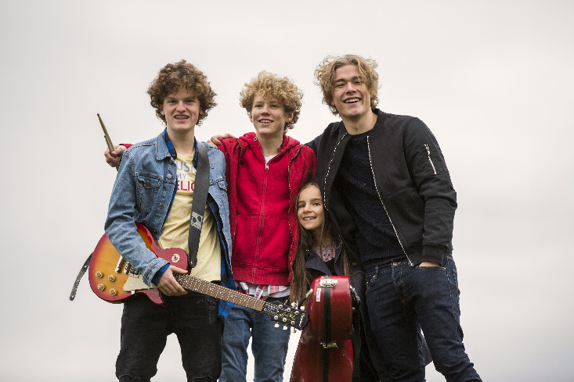
LOS BANDO
From Norway
Directed by Christian Lo
Two best friends, Grim and Axel, have dreamed since they were eight about competing at the annual Norwegian Championship of Rock. Together they have a band but they lack a bass player, and have to let 9-year-old Thilda become their bass player – on cello. Their driver usually competes in rallies and all together they embark on a crazy journey in a race against the clock to avoid their parents and the police and get to the Championship!

OLD BOYS
From the UK
Directed by Toby MacDonald
In a posh boys’ school, Amberson is one of the poorer boys, and also a bit of a nerd. But he’s not just awkward, he’s also fantastically imaginative and good with words. When the handsome, rich but not very clever Winchester needs help to impress a girl (the new French teacher’s daughter) he turns to Amberson, who pours his own secret feelings for Agnes into poetic notes, videos and some very odd gifts…

FIND OUT MORE!
yaa.europeanfilmawards.eu
facebook/YoungAudienceAward
European Film Academy Young Audience Award

TWO QUESTIONS FOR JURORS
Please return this and the Consent Form to us by Mon 29 April!

1. We are looking for jurors who like watching different kinds of films. Can you give us the names of 3 different films which you have liked, and one sentence about each to say why you liked it? The films can be old, new, animated, comedy, adventure, documentary…

2. The films we’ll watch are from the Netherlands, Norway and the UK. The two from the Netherlands and Norway are subtitled. They’re about young people’s lives, a mix of fun and more serious subjects. Have you watched a film about a serious issue for young person before – what was it about? What did you think of it?
If you haven’t seen one, please just leave this box empty.

Consent form and transfer of rights
As parent and legal guardian I hereby give consent for my child to participate in the EFA YOUNG AUDIENCE AWARD on 5 May 2019 and for film and audio recordings of same to be made. It is also possible that film and audio recordings (e.g. interviews) will be made prior to the ceremony and may be identified with a picture and/or name of my child. Furthermore, I hereby consent in advance to these film and audio recordings of the EFA YOUNG AUDIENCE AWARD event and the ceremony of the EFA YOUNG AUDIENCE AWARD on 5 May 2019 in Erfurt (Germany) being used by EFA Productions GmbH at its sole discretion in respect of frequency, whether in whole or in part, and without limitation in respect of time, purpose and location, for broadcasting and non-broadcasting uses of any kind (TV, radio, print media, audio visual uses, in particular internet and live-stream etc.). These broadcasting rights are transferred for all broadcasting technologies, standards and formats as well as for the transfer to third parties.
In case this rights waiver is translated into another language than English, both language versions shall be signed and in case of any discrepancy the English text shall prevail.

_____________________________________________________ _______________
Surname, first name of child Date of Birth

______________________________________________________
City, country

Legal guardian(s):

______________________________________________________
Surname(s), first name(s)

______________________________________________________
Street, house number

______________________________________________________
Location, post code

____________________ ______________________________________
Location, date Signature of legal guardian

